<https://drive.google.com/file/d/1LG0WIG_UYr7SHrQnEhRL8Yj4kMIY2vSn/view>

<https://www.sreeharshav.com/devops1>

**Kops cluster explain URL**: https://www.youtube.com/watch?v=0f8OuyqbA5E

**Road map URL:** <https://www.techworld-with-nana.com/post/kubernetes-roadmap?utm_source=youtube.com&utm_medium=video&utm_campaign=yt-description-k8s-roadmap-2023>

**Doc Refer**: https://medium.com/@bijit211987/kubernetes-roadmap-edd06067fa72

**Refer URL:** <https://roadmap.sh/kubernetes>

https://www.techworld-with-nana.com/kubernetes-roadmap

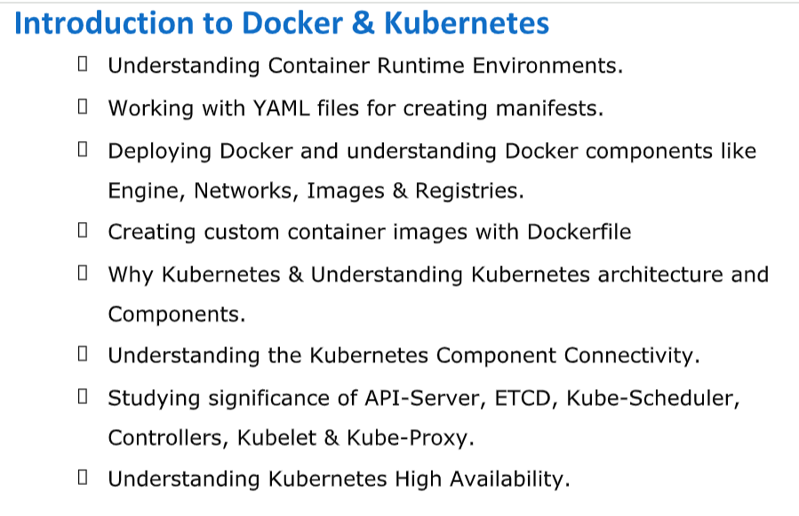

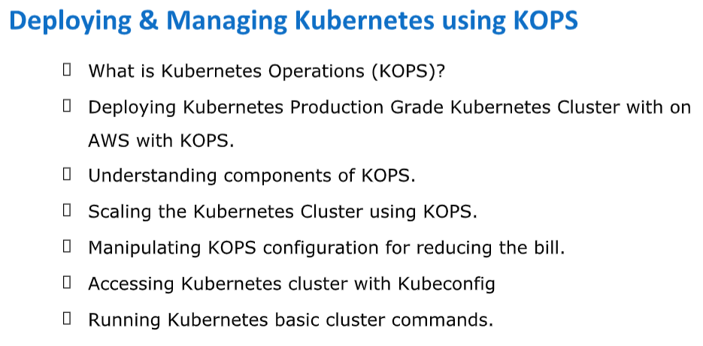

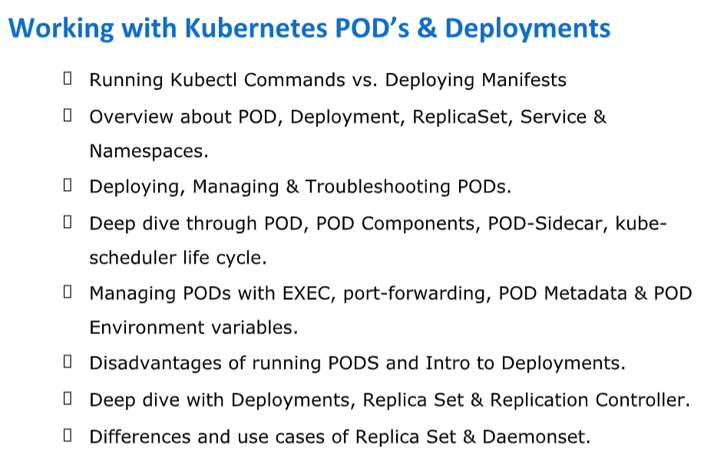

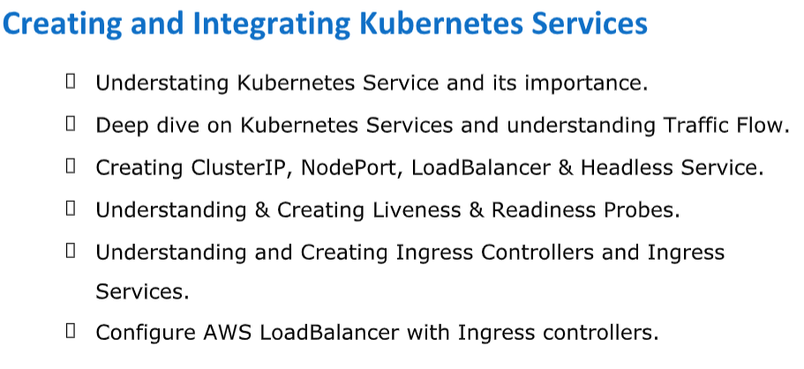

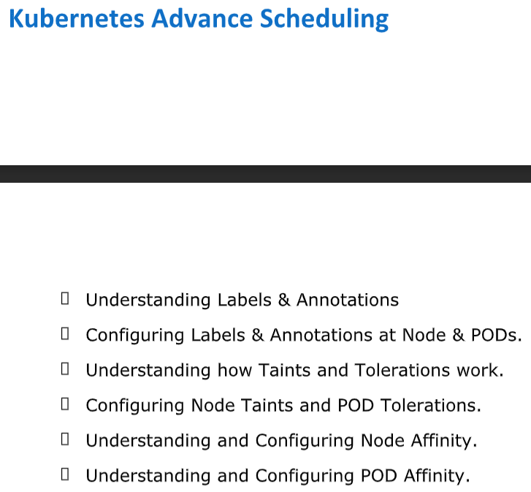

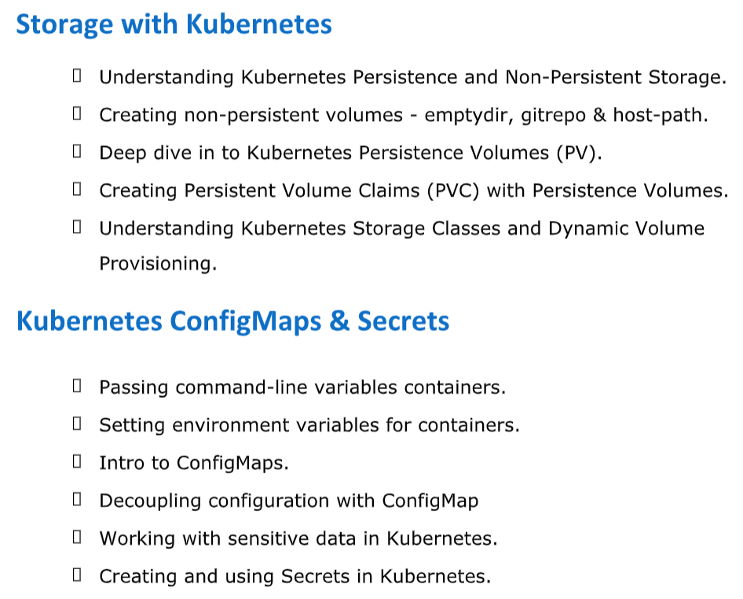

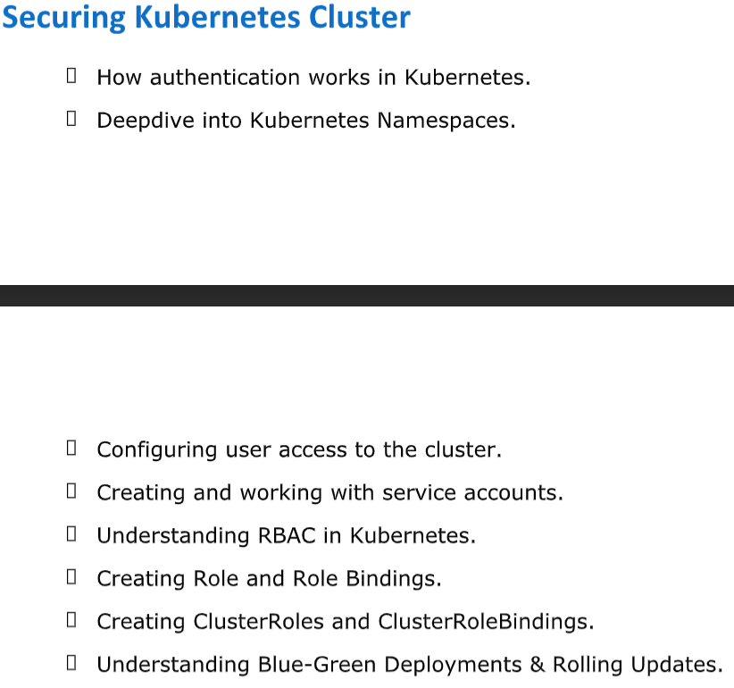

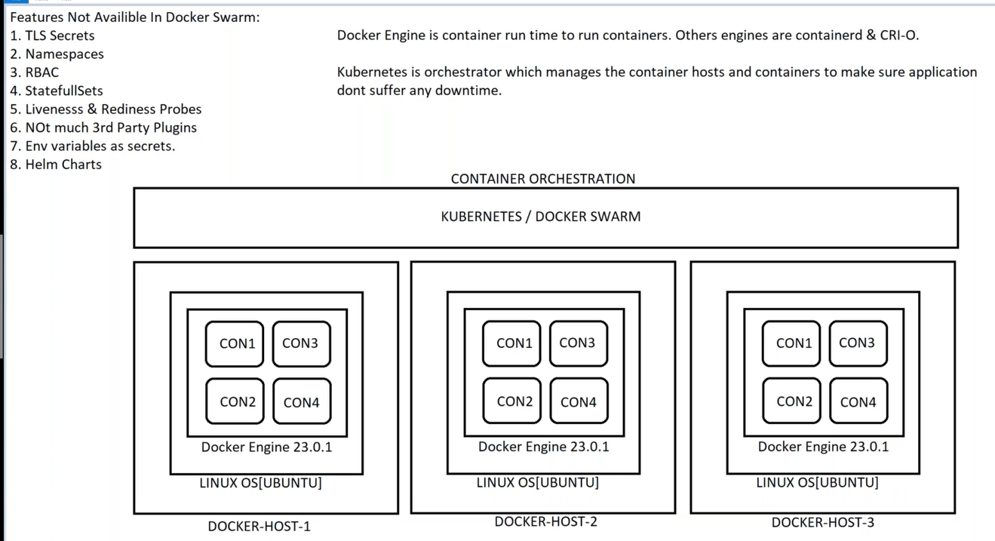

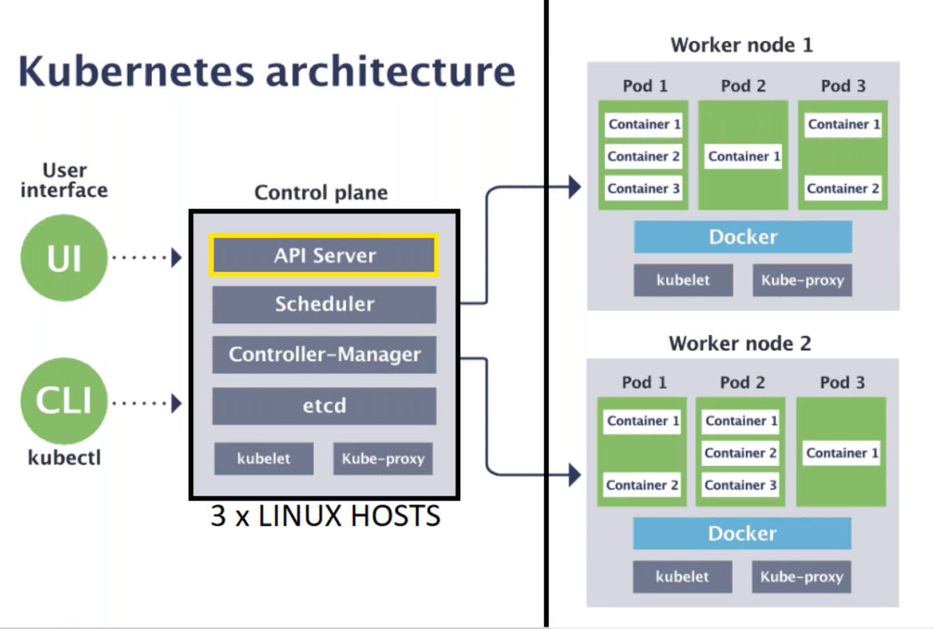

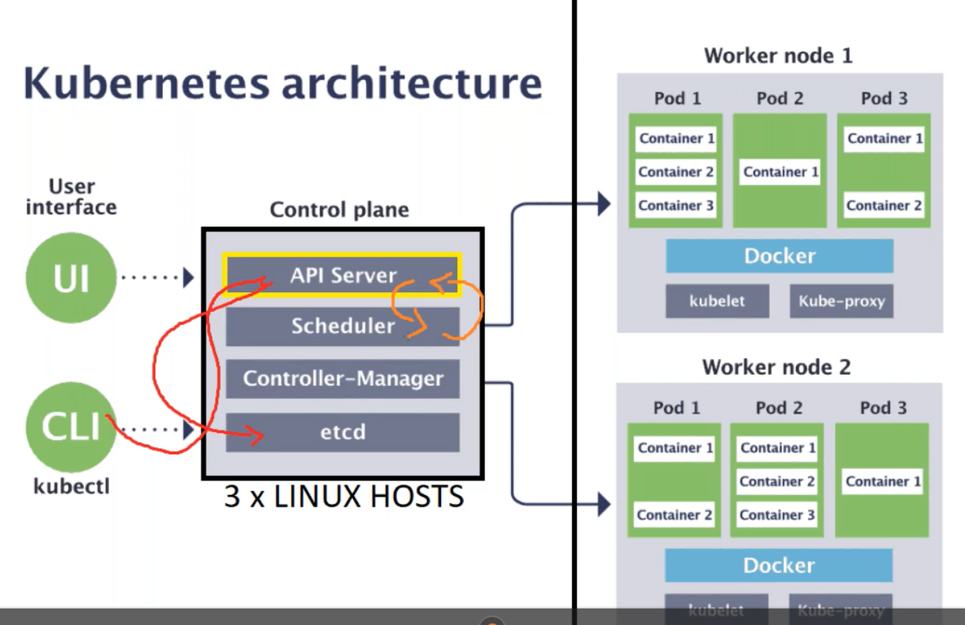

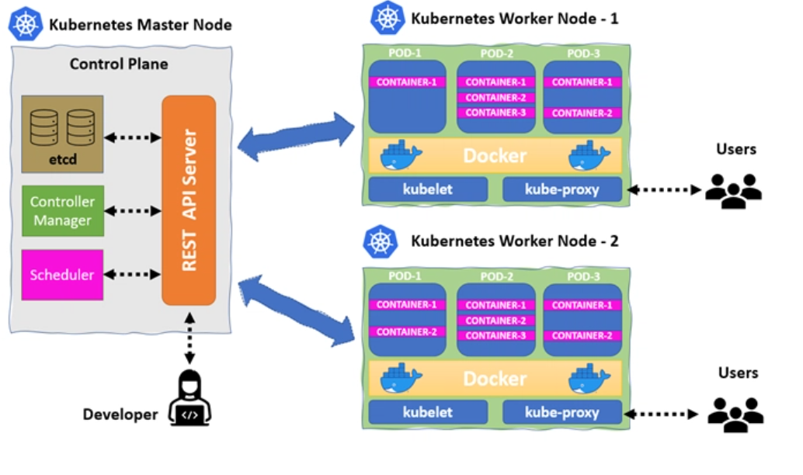

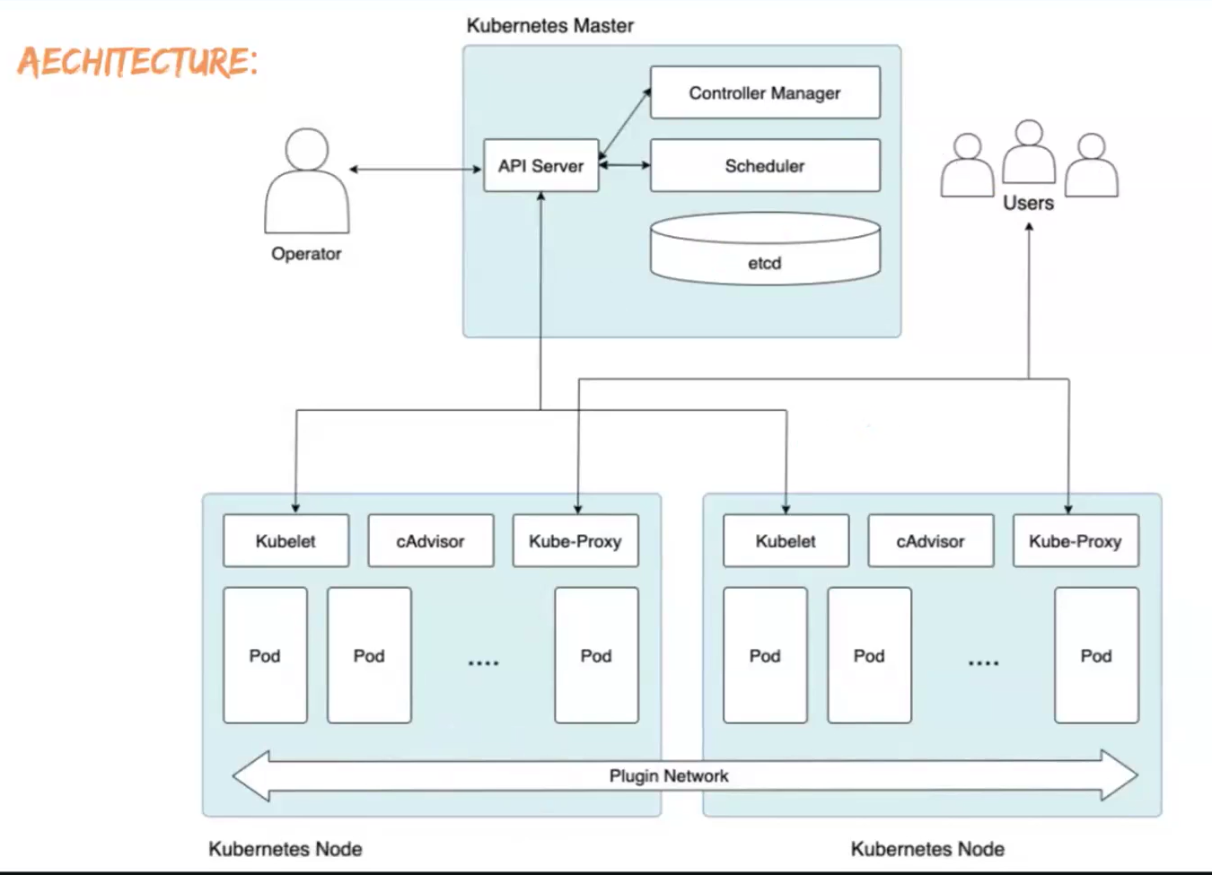

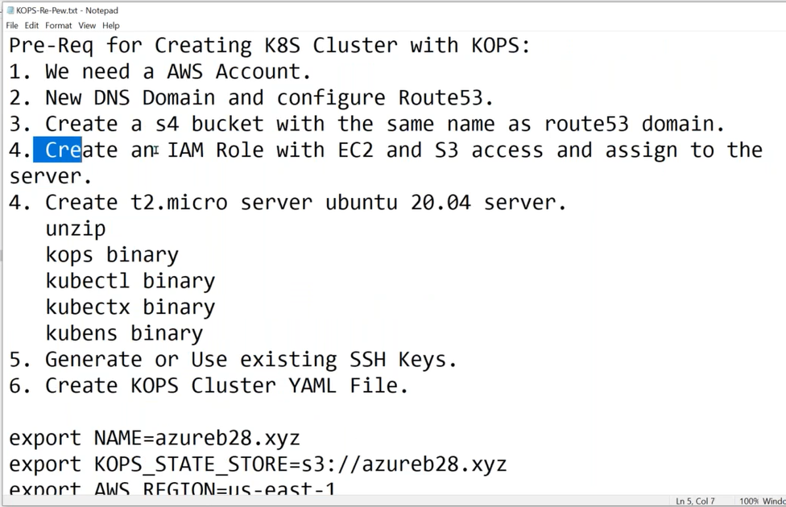

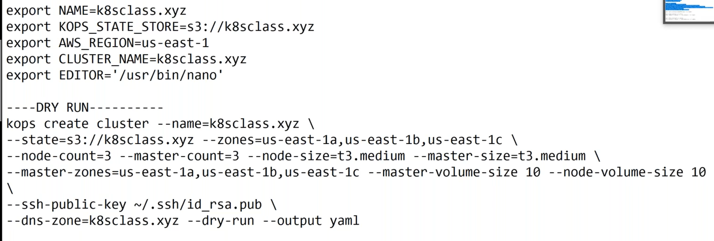

**Session-2:**

**Kops Cluster creation**

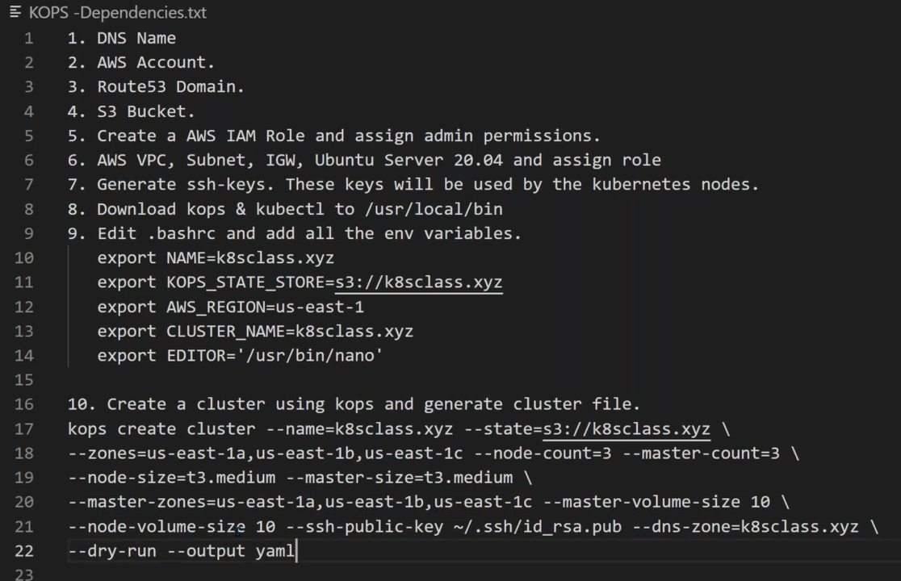

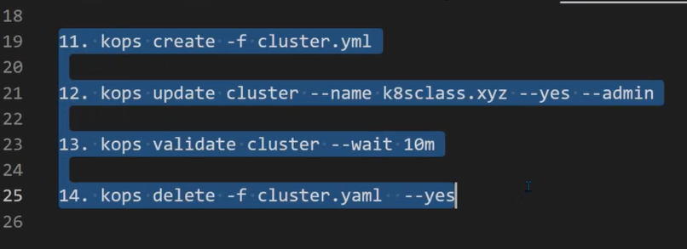

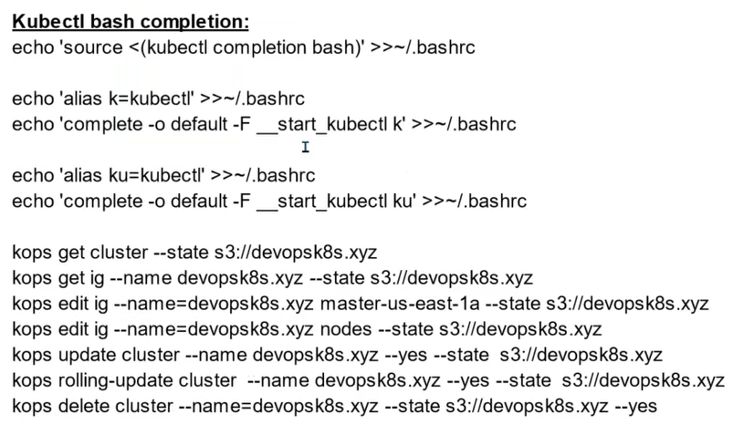

**In Kubernetes kops cluster why we do smoke testing**

**Smoke testing** verifies that a Kubernetes cluster is functioning as expected after a new deployment or upgrade. It reduces downtime risks and ensures reliable deployment by identifying potential issues early on.

**Smoke - Testing**

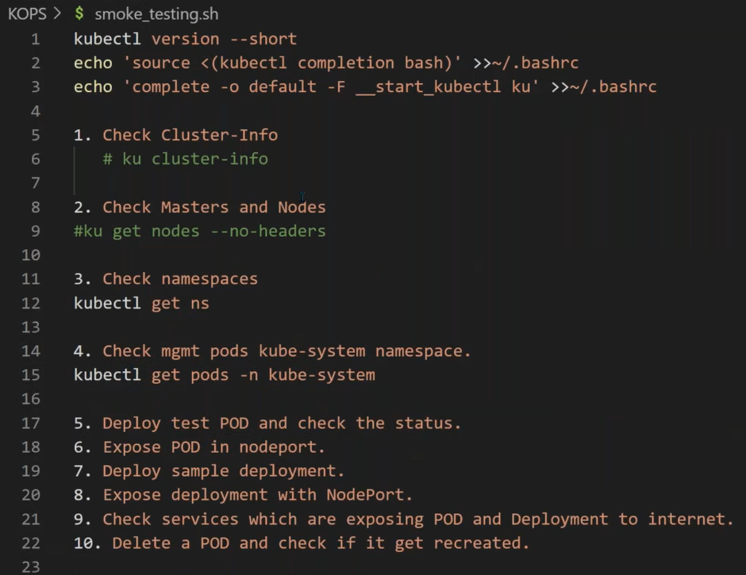

What is Master and Worker node components in a Kubernetes cluster?

Session:3

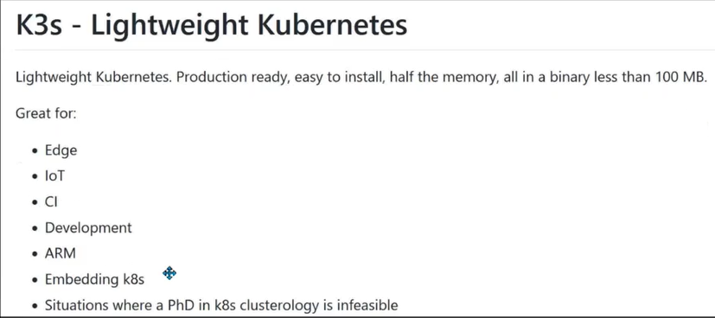

**Session-4**

**Today Class discusses Topic’s.**

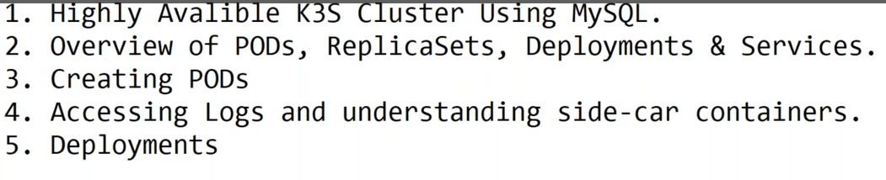

**What is POD in k8s?**

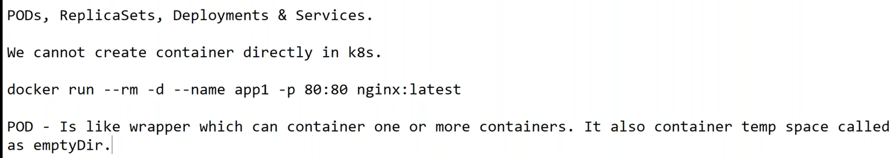

What problem does Kubernetes solve?

What are the issues when operating large, containerized apps?

What are the benefits of using Kubernetes?

what are the core objects of Kubernetes?

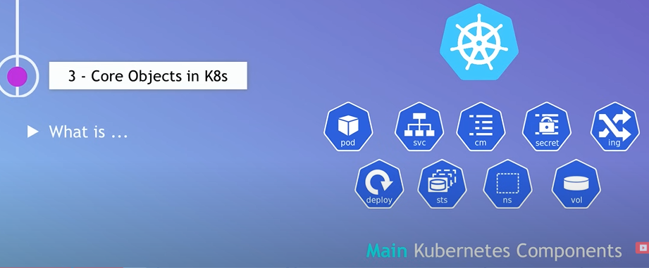

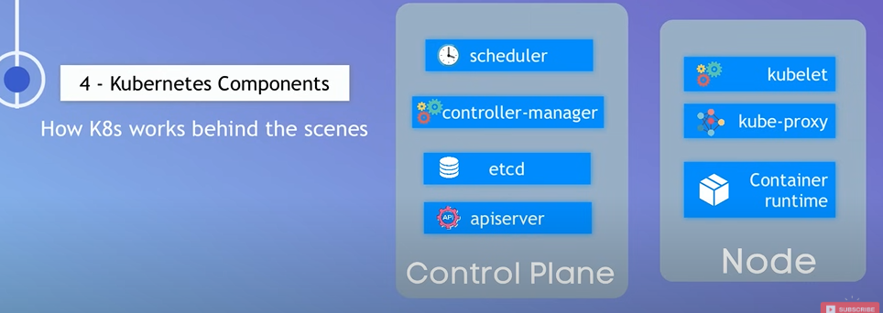

**Session:5**

Deployment

Deamon Sets

Stateful sets

**What is Pod?**

**Imp Refer URL:** <https://kodekloud.com/blog/pods-in-kubernetes/>

🡺Pods are the fundamental building blocks of the Kubernetes system. They are **used to deploy, scale, and manage containerized applications in a cluster.**

🡺 A Pod can host a **single container** or a **group of containers** that need to

"Sit closer together". By grouping two or more containers in a single Pod, they will be able to communicate much faster and share data more easily.

🡺 when a Pod contains **multiple containers**, all the containers **always run on a single worker node**. They never span across multiple worker nodes.

**Replica-Set 🡪 Make sure that desired number of Pods run at all times.**

🡺 The Replica Set ensures that the desired number of replicas (copies or Pod ) **are running at all times by creating or deleting Pods as needed**.

🡺 It is part of the desired state management of Pods.

**Deployments** 🡪 Apps are deployed using Deployment resource.

🡺A higher-level abstraction for managing ReplicaSets and Pods.

🡺 Deployments allow declarative updates to applications and facilitate rolling updates and rollbacks.

🡺 99.9 % all are using Deployments applications using.

**3-Node cluster creation Command**

kops create cluster --name=<Cluster_Name Ex: k8sclass.xyz> \

--state=s3://<S3BucketName Ex: k8sbatch17.xyz> --zones=us-east-1a, us-east-1b,us-east-1c \

--node-count=<No of Node count Ex: 3> --node-size=t3.medium --master-size=t3.medium \

--master-zones=us-east-1a, us-east-1b,us-east-1c --master-volume-size 10 --node-volume-size 10 \

--ssh-public-key ~/.ssh/id_rsa.pub \

--dns-zone=<Route 53 DNS Name Ex: k8sbatch17.xyz> --yes

🡺 **3-Node Cluster Creating**

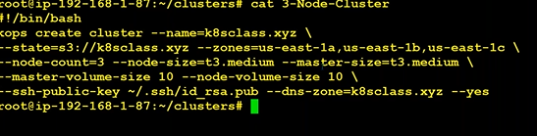

kops create cluster --name=jagando.online \

--state=s3://jagando.online --zones=us-west-2a,us-west-2b,us-west-2c \

--node-count=3 --node-size=t3.medium --master-size=t3.medium \

--master-volume-size 10 --node-volume-size 10 \

--ssh-public-key ~/.ssh/id_rsa.pub \

--dns-zone=jagando.online --yes

**Labels:**

🡺Labels are **key-value pairs attached** to Kubernetes **objects such as pods, services, and deployments.**

🡺They can be used to select and group subsets of objects in the cluster. Labels are added to an object in the **metadata labels section** of the object descriptor as shown in the two Pod definitions below.

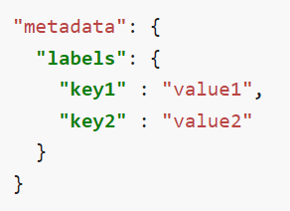

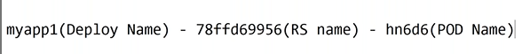

**What is annotation in Kubernetes?**

🡺 Annotations in Kubernetes (K8s) are metadata used to express additional information related to a resource or object.

🡺 Annotations consist of key-value pairs, each pair used to describe the resource’s metadata or provide additional information.

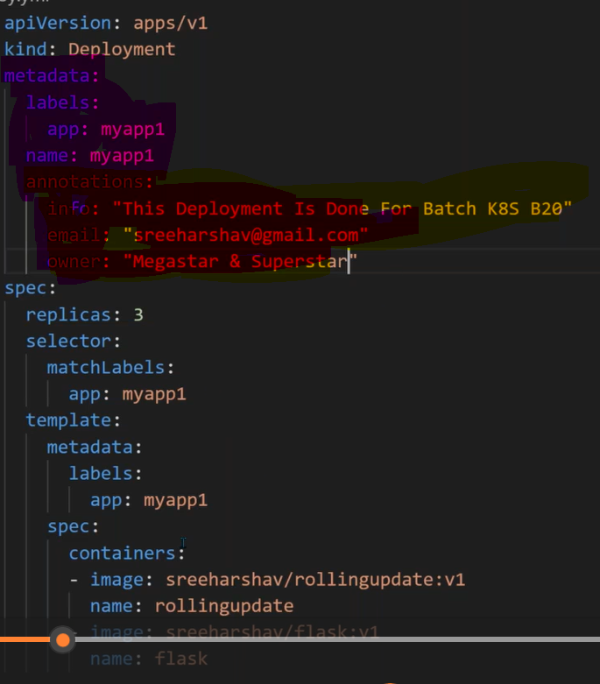

**Imp interview Question:**

**Reference URL:**

🡺 https://medium.com/@muppedaanvesh/deploying-nginx-on-kubernetes-a-quick-guide-04d533414967

**Created a deployment any one application (nginx) server in Kubernetes.**

Ex:

**apiVersion**: apps/v1

**kind**: Deployment

**metadata**:

**name**: nginx-deployment

**labels**:

**app**: nginx

**spec**:

**replicas**: 3

**selector**:

**matchLabels**:

**app**: nginx

**template**:

**metadata**:

**labels**:

**app**: nginx

**spec**:

**containers**:

- **name**: nginx

**image**: nginx:1.14.2

**ports**:

- **containerPort**: 80

**What is the difference between DaemonSet and Deployment?**

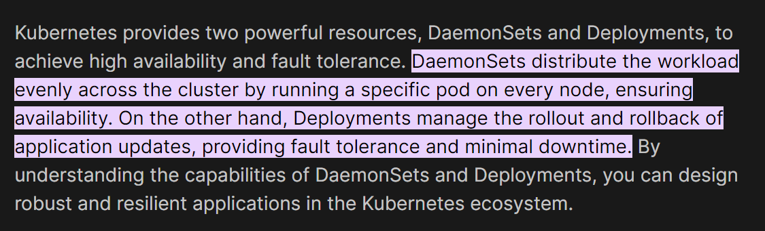

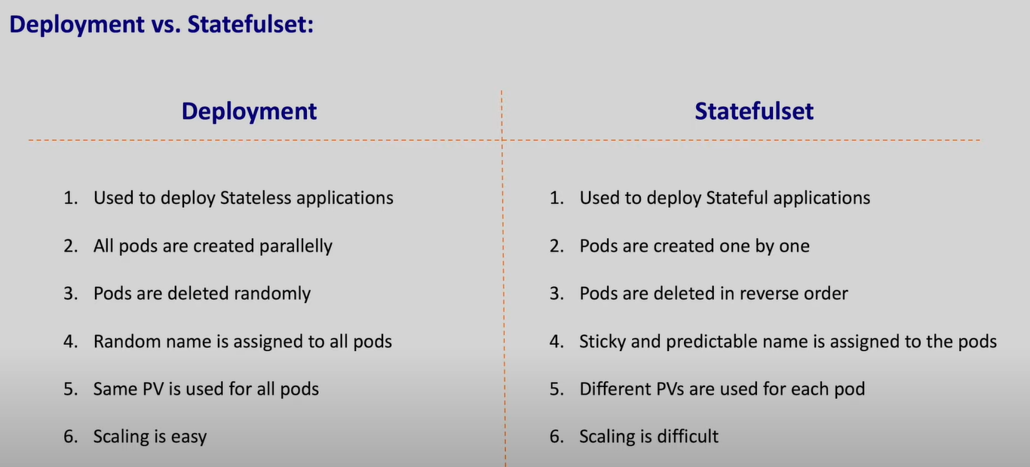

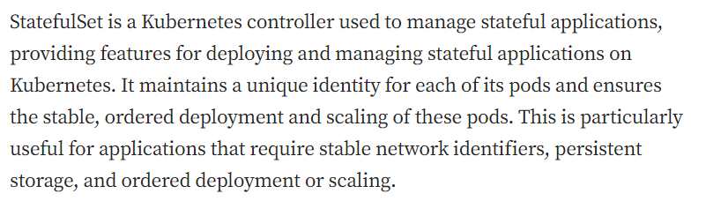

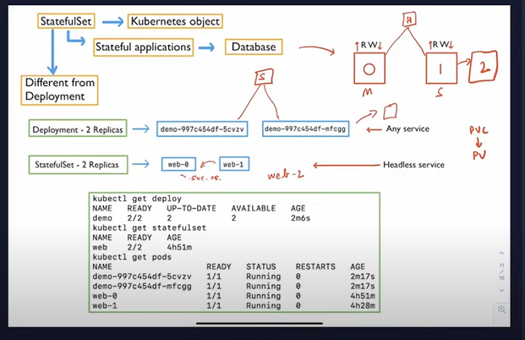

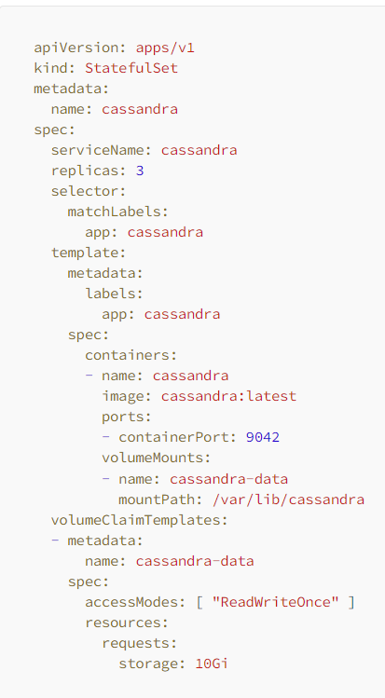

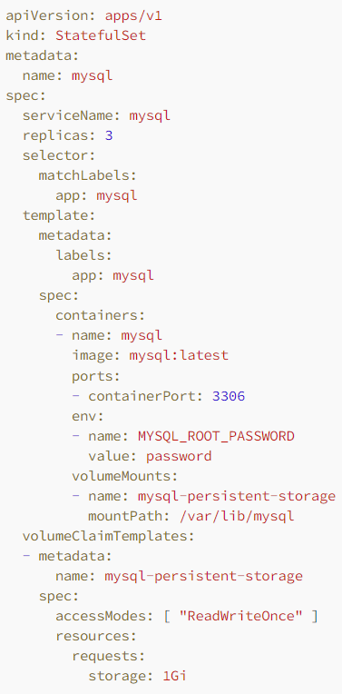

**Session: 6**

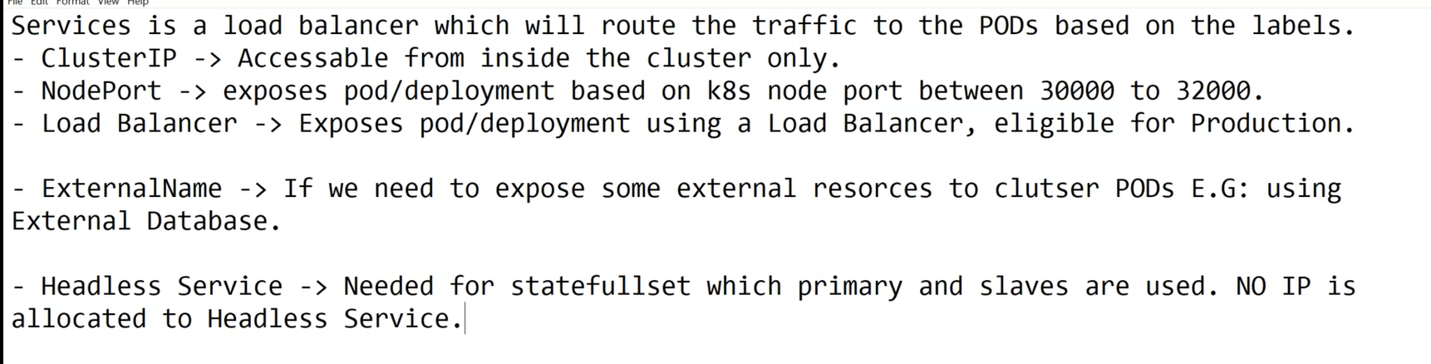

**Creating Cluster IP servers:**



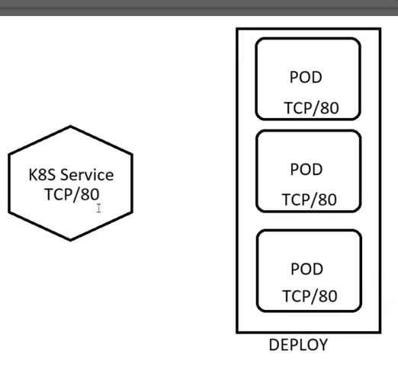

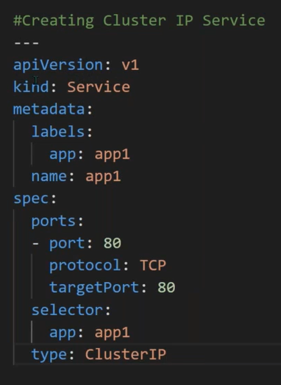

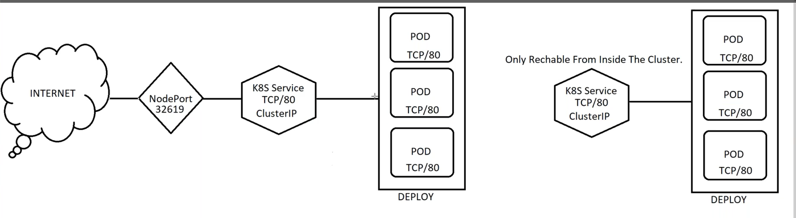**External Name Ex:**

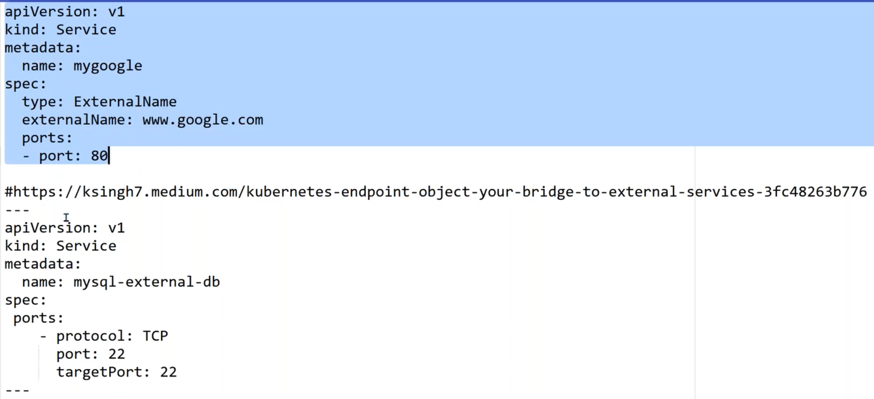

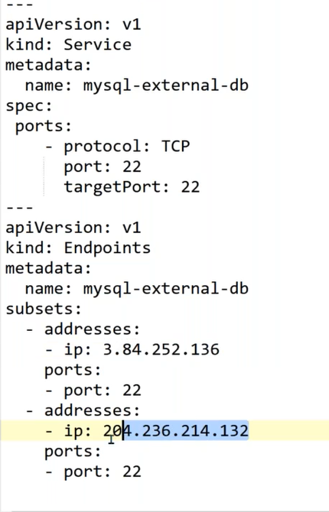

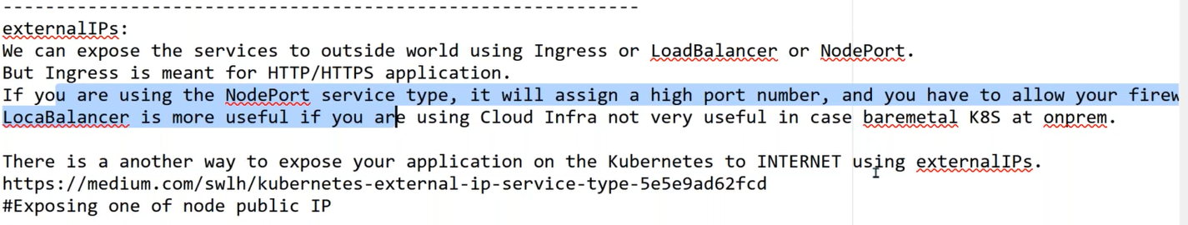

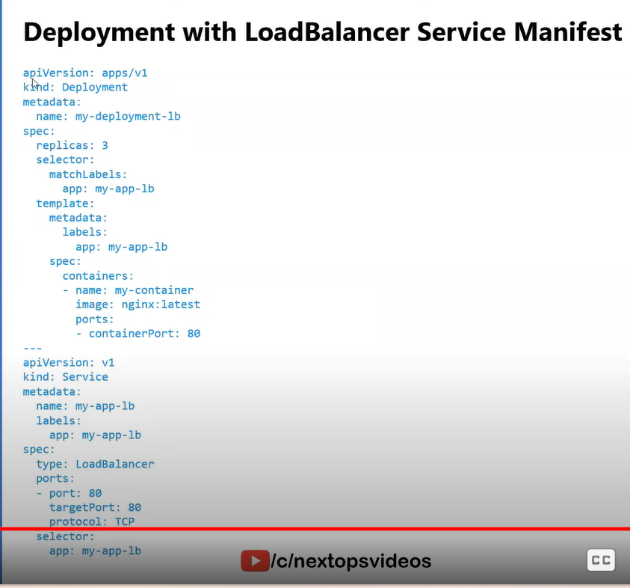

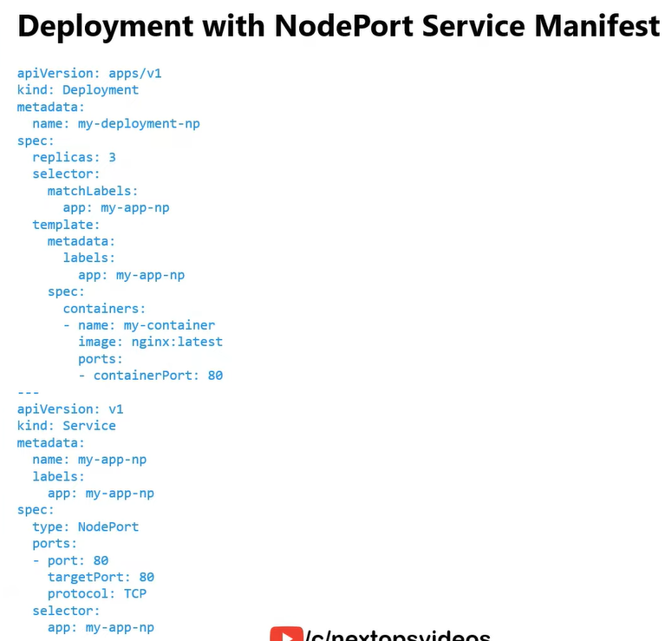

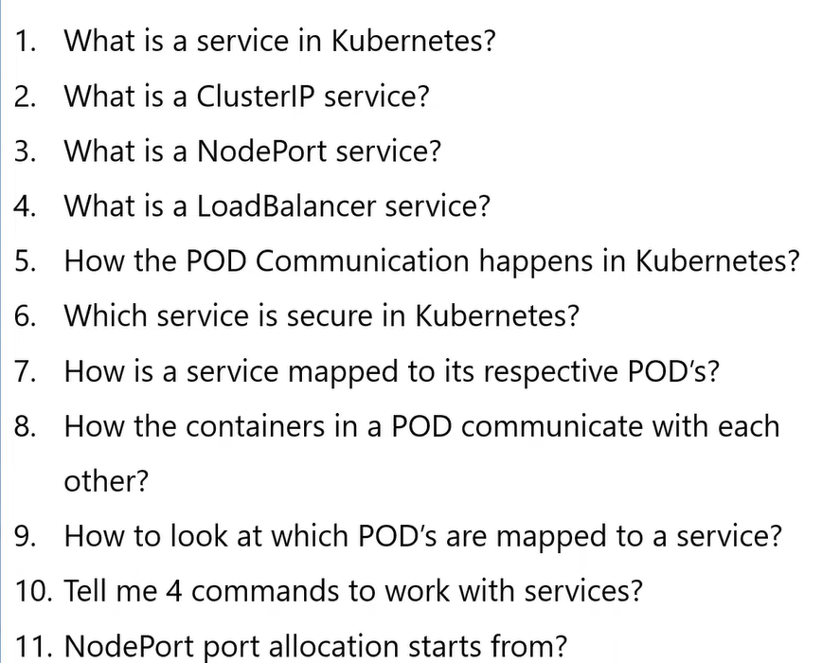

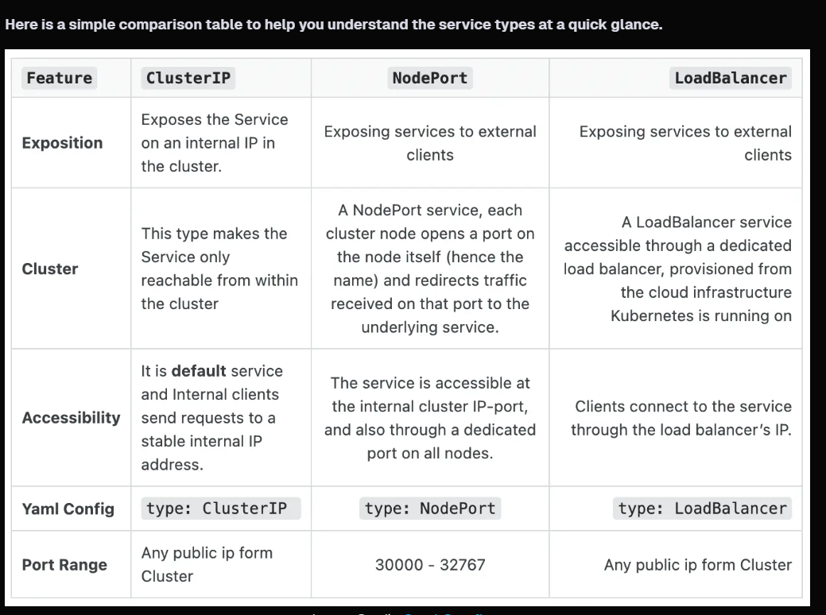

Session:7

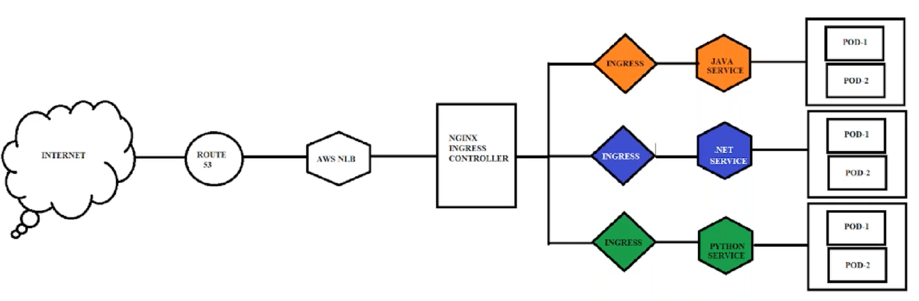

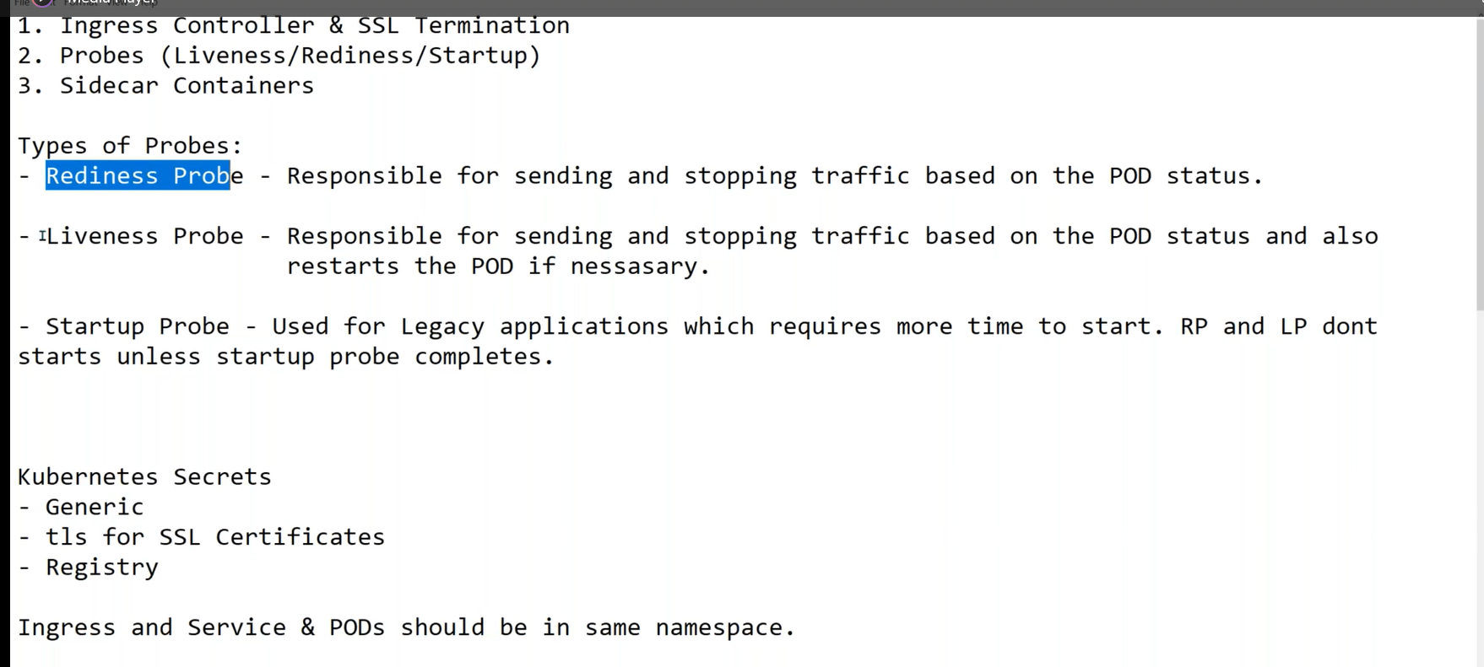

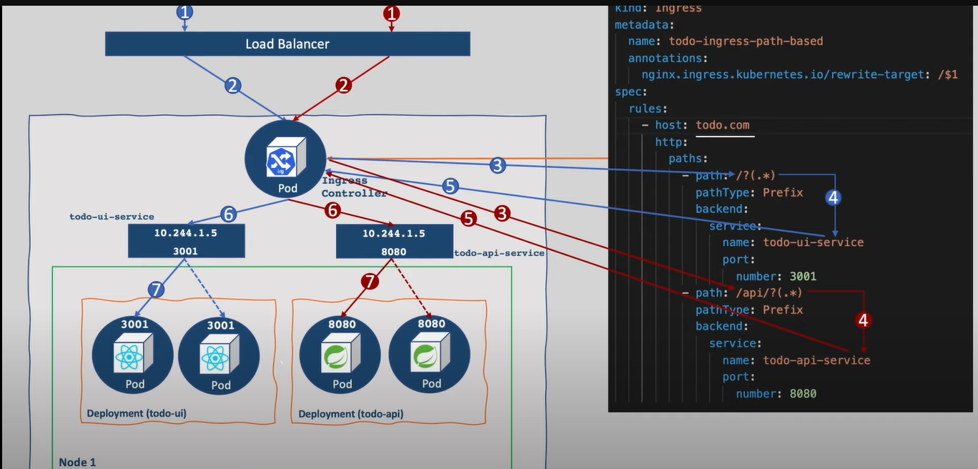

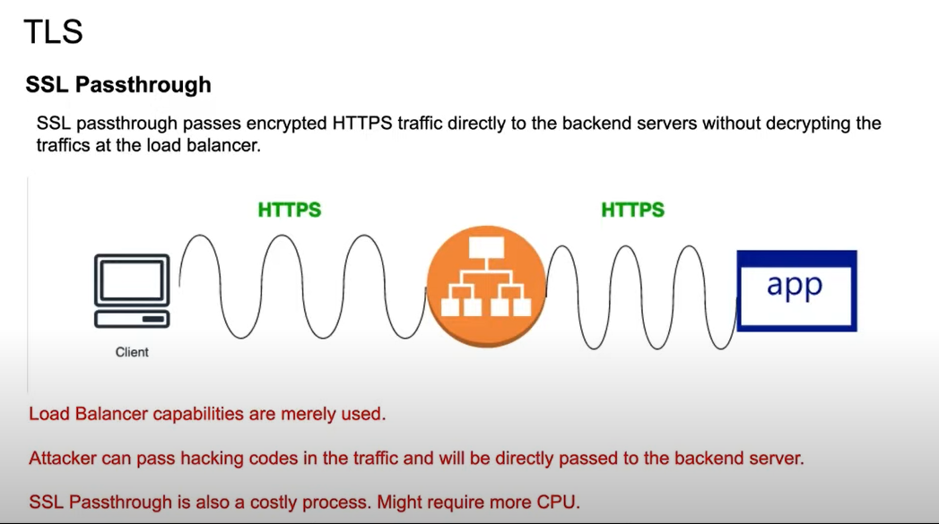

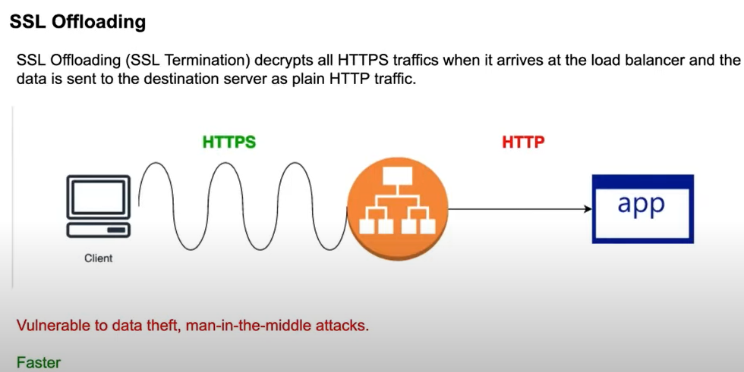

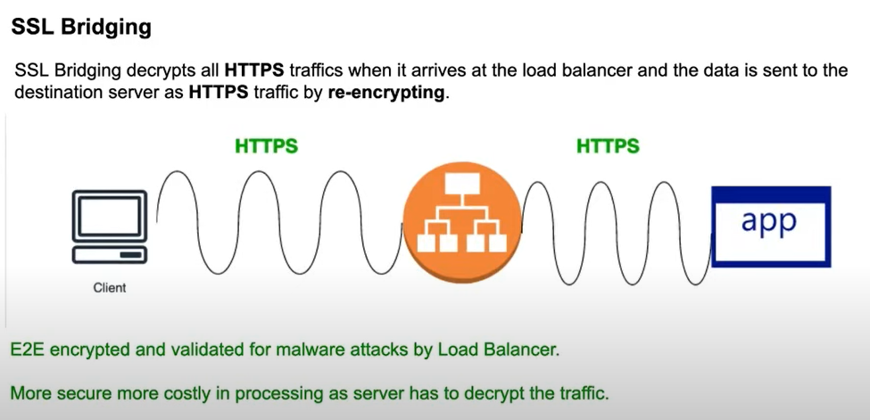 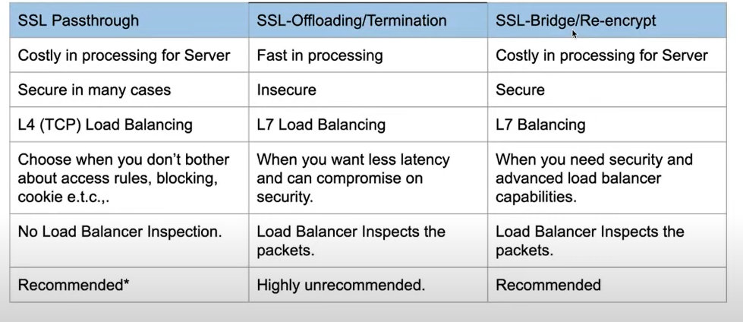

**Session: 8**

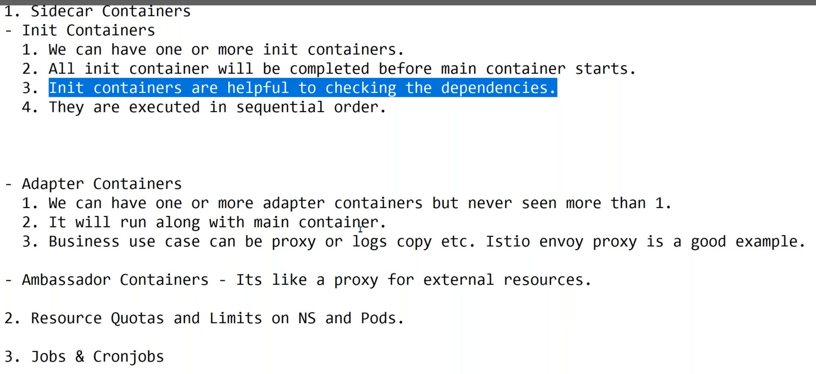

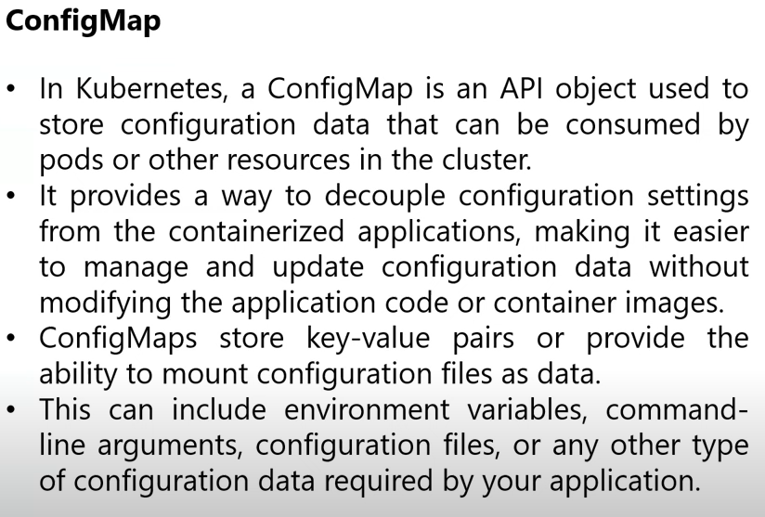

**What is Name Space?**

**Session: 9**

**K8s RBAC**

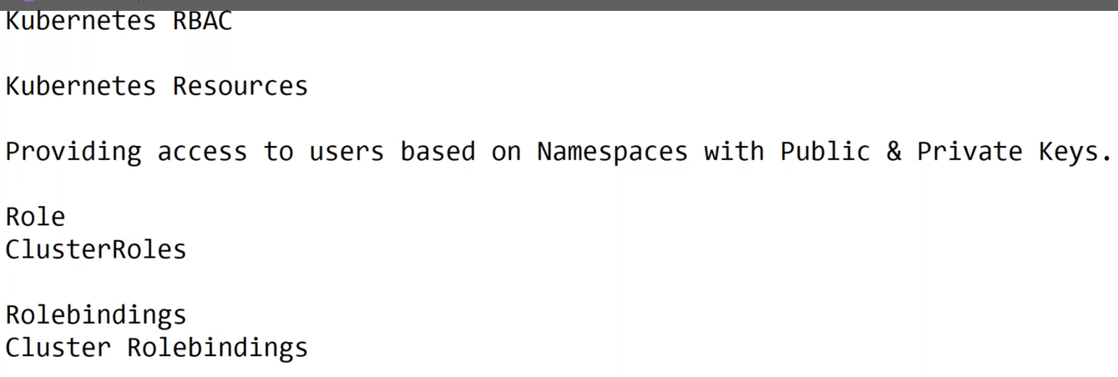

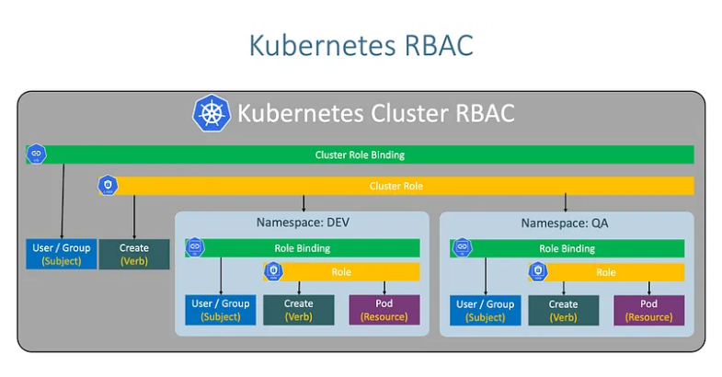

Refer URL: https://medium.com/@nbkumar2103/-f7d2535f57bc

**Session10: Secrets & Configmap**

**Session11: Storage in k8s**

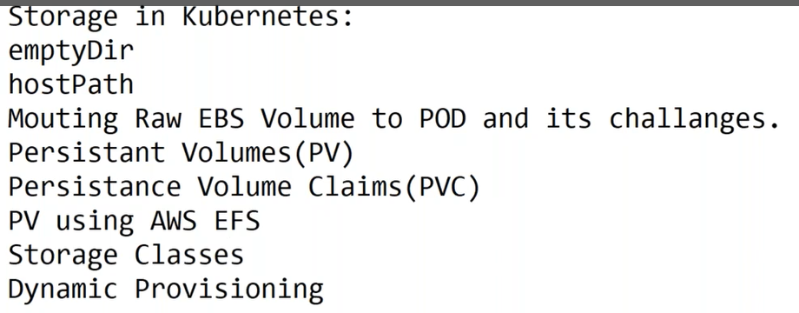

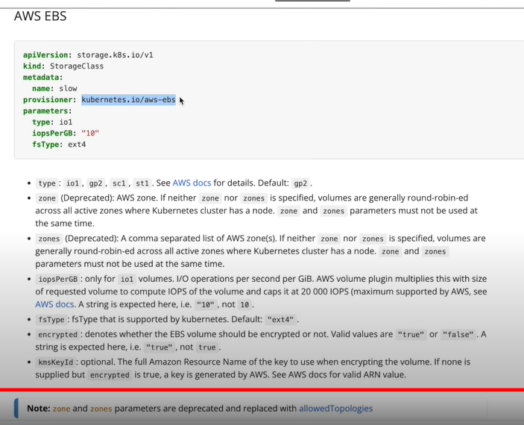

**Session:12**

**Network Policies:**

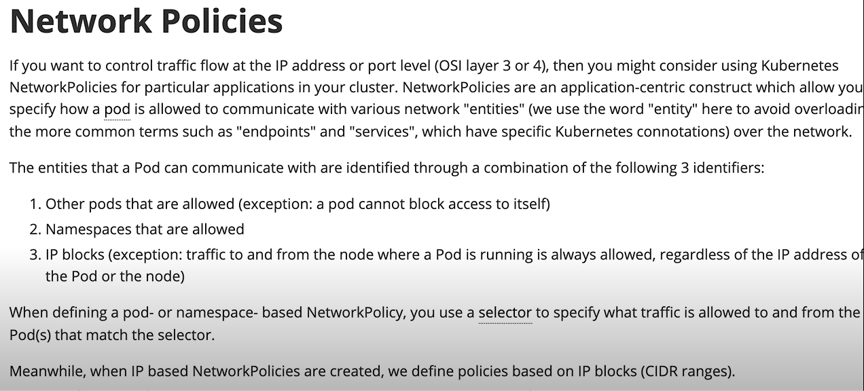

**Session: 13**

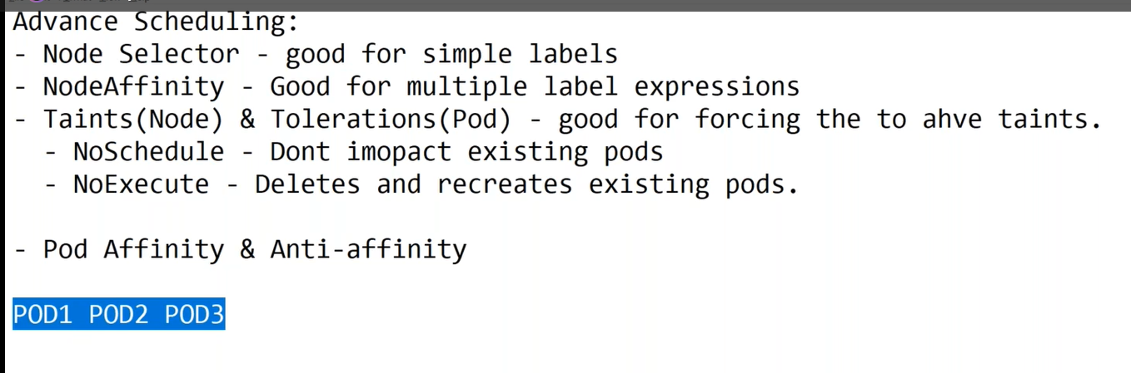

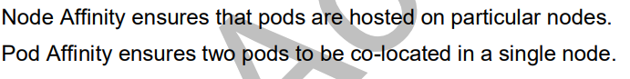

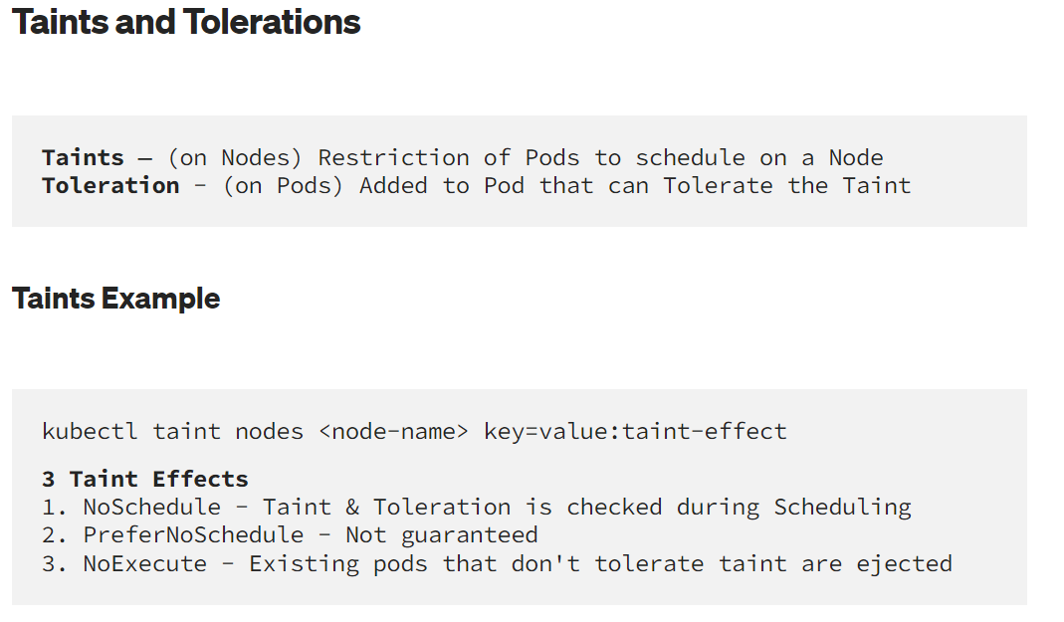

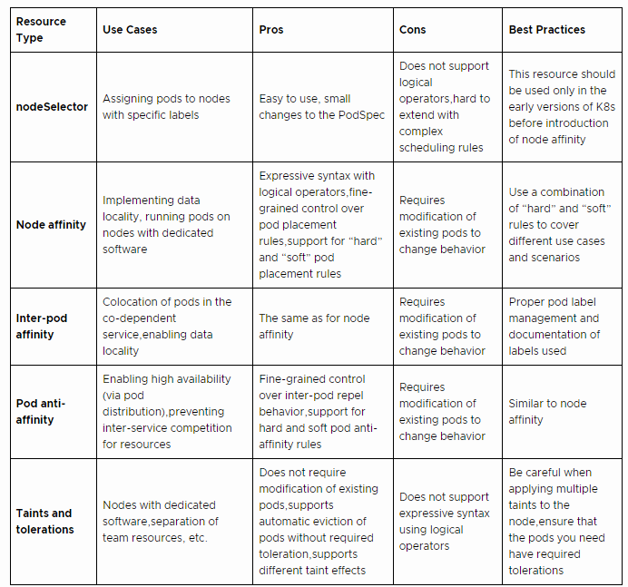

**Session: 14:**

**Service Mesh – Istio**

**Session: 15**

**Prometheus and Grafana**

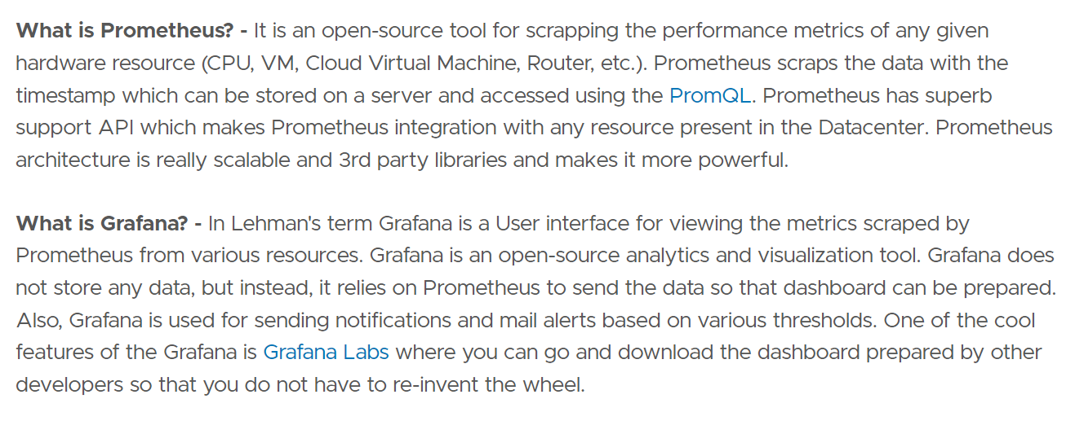

**Install**

**How to setup Prometheus, Node Exporter and**

**🡺** Grafanahttps://jhooq.com/prometheous-grafan-setup/

**🡺 https://prometheus.io/download/**

**linux -** Grafanahttps://jhooq.com/prometheous-grafan-setup/

🡺$mkdir Prometheus

🡺 $ cd Prometheus/

🡺 $ wget Grafanahttps://jhooq.com/prometheous-grafan-setup/

🡺 **Extract the download binary file:**

**-$** tar xvfz <File name (prometheus-x.xx.x.linux-amd64.tar.gz)>

🡺 $ ls -lart

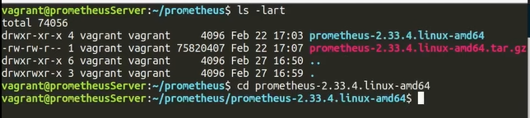

🡺 $ cd Prometheus-2.33.4.linux-amd64

🡺$ ls -lart

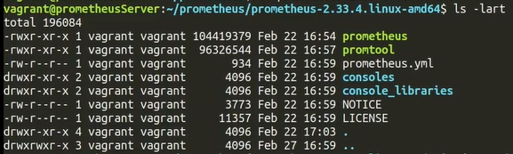

🡺 $ ./Prometheus

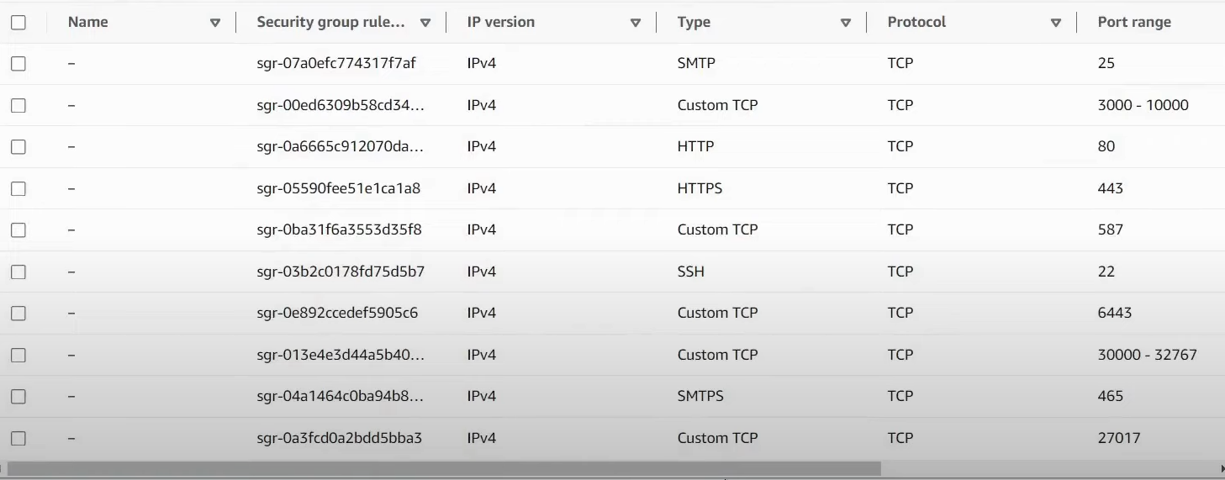

**Session: 16**

**1. Helm-charts**

🡺 Helm helps you manage Kubernetes applications — Helm Charts help you define, install, and upgrade even the most complex Kubernetes application.

🡺Charts are easy to create, version, share, and publish — so start using Helm and stop the copy-and-paste.

**2. Kustomize** – Less complex and easy to use.

Session: -17

AWS EKS Deployment

**Session:18**

**Azure AKS**

**Session:19**

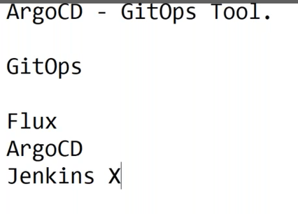

**Session: 20**

